Measurement and Evaluation for Learning and improvement

Optional Extensions

Version 2.0 October 2025

Theory of Change
The creation of a Theory of Change (TOC) is optional, but highly encouraged, for all initiatives. It should be developed at the proposal design phase of the initiative grant. It does not replace the Rubrics Template, but it serves to inform the appropriate overlap with the Laudes TOC and then the selection of rubrics for measuring change.
There are many definitions of a ‘theory of change’ (TOC) – in essence; it is a blueprint of the building blocks needed to create long-term social change. Building blocks strategies for intervening; early and later expected changes, outcomes, assumptions (supportive and those that will ‘kill’ the pathways towards impact) and contexts (policy, political, environmental, socio-economic, cultural) within which an initiative (single or multiple) or organisation is embedded, that are necessary to achieve impact(s).
The key value of a TOC is that it visually conveys beliefs about why the initiative, programme or organisation is likely to succeed in reaching its goals. Unlike a logical framework, which is associated with focused and discrete initiatives, a TOC can be developed for strategies, programme(s), initiatives, groups of organisations working together towards common goals (collective impact), convenings and research initiatives.
The Theory of Change template is given below, and the arrows can be moved to draw the causal pathways.
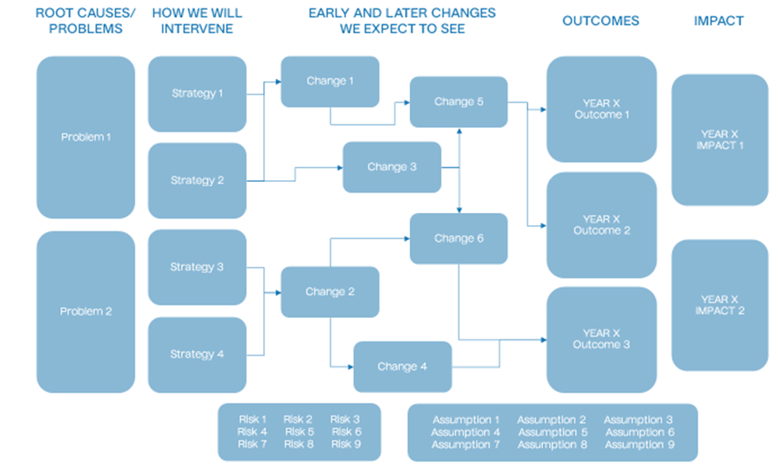
Our advice on the creation of a Theory of Change:
- The TOC is optional for any initiative grant size. For initiative grants more than €100K the TOC will align with, enable an appropriate selection of rubrics.
- Having a TOC is encouraged for partner organisations receiving General Operating Support.
- The TOC should define causal pathways moving from early / later changes to outcomes. It will identify the problem statement, assumptions and risks. A TOC template is given in Annex 2 alongside questions to be posed while developing and preparing it. The TOC may also link to the Laudes Foundation Theory of Change.
- The TOC should be developed by the partner. Advice to develop a TOC can be provided by the Effective Philanthropy Team or an approved consultant on request.

Suggested Guiding Questions to Develop a Theory of Change
What are the root causes that lead to...?
- What are the "problems" and "needs" that reinforce them in vicious cycles?
- What are the "rights" and "potential" that weaken them in virtuous cycles?
- What would be the fundamental principles of a system that supports an inclusive and regenerative economy?

How would you intervene in the system?
- Which leverage points are important for creating enough pressure to 'flip' the system?
- How would you intervene in those leverage points?
- What activities, resources and alliances, would you need?

Where and under what circumstances will changes need to take place?
- What are some context scenarios that could make system shift difficult
- What are some context scenarios that could derail key pathways to change?
- For both, consider political, cultural, economic, mass migration, Covid-19 (pandemics), significant climate events, etc.

Why do you believe your theory will hold true?
- What are your assumptions?
- What are the threats to your strategy(-ies)?

How would you know if you're moving in the right direction or not?
- What are the early signs of traction likely to be?
- What about early signs of failure?
- What will be the key elements needed to embed changes in the system and make it impossible to revert back to the previous state?
- How will you know when the new state is sufficiently stable?
- If your strategy works, what kind of results do you expect to see in 2 years? And in 3-5 years?

External Evaluations

External evaluations are carried out according to the M&E plans, and only when there is a clear need and intended use for them. Their main purpose is to assess the outcomes of an initiative, looking at where and how the initiative contributed to changes using rubrics criteria and rating progress.
They will take a responsive approach to gender, equity, and inclusion, both in design and implementation, and include appropriately disaggregated data.
Eligibility criteria include:
- There is strong interest from programme teams and partners in learning from an external evaluation.
- The initiative is not part of an existing cluster of similar grants working toward the same outcomes.
Evaluator selection:
The evaluation will be conducted by an evaluation expert who understands the local and regional context. During the selection process, we aim for gender balance in the evaluation team.
Evaluation outputs will include:
- When the evaluation took place
- Who was involved
- Key questions and methodology (including how rubrics were applied)
- Context of the initiative
- Findings, recommendations, and lessons learned
Oversight and coordination:
A Senior Evaluation Manager will advise on the budget, select consultants, and oversee the evaluation in close collaboration with the partner and Programme Manager. Both the partner and the foundation will be invited to provide a management response to the evaluation. However, either party may choose not to respond.
Transparency on ‘what we are learning’: All external evaluations funded by Laudes Foundation are open-access and published. Evaluations are published unedited and without redaction of evidence or findings.

